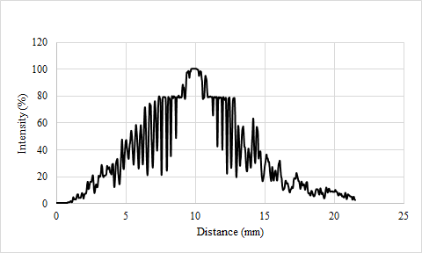

ON QUANTUM PHENOMENA IN MODERN PHYSICS

PERFECT ABSTRACT:

Modern physics, the study of natural phenomena which resists classical explanations, has received considerable attention of late in both scientific and amateur media. This report compiles various effects relating properties of light known since antiquity and quantum ideas theorized in the late twentieth century, including the computation of Planck’s constant to be (6.5±.9)Js and derivation of the uncertainty principle: $σ_{y}⋅σ_{Py}=h$. The efficiency of the tested LEDs was also analyzed, and due to the inefficiencies in semiconductors, (3.8±.7)E-20 J of energy was lost as heat per electron. Theoretical models have been applied to camera technology, including suggestions to improve camera sensor accuracy and calibration.

INTRODUCTION

The structure of light is one of the few remaining questions posed since antiquity—and humanity has still been unable to answer. This report is not intended to solve this mystery, but rather to submit evidence to the collective theories mankind is developing.

SOURCES OF ERROR

The uncertainty principle affirms an inevitability in the universe: an observer cannot be certain of anything, even if they had flawless equipment and methodology. This report, without flawless equipment or methodology, does much worse.

Due to time constraints, certain equipment could not be thoroughly tested, and in the case of the HeNe lasers and temperature of the light bulb filament, could not be tested at all.

Further, certain logical errors exist. The uncertainty principle has been derived from the single slit experiment, but in no way has it been proven. There exist many classical explanations for the diffraction effect, and this report serves only as evidence for modern theories, not a concrete proof.

CONCLUSION

The results of this report have many practical applications, including implementations in display technology, and cameras, as well as in other disciplines of science such as chemistry. This report is intended as a stepping stone towards further research—next steps include stronger evidence for the uncertainty principle, as well as deeper experimental imaging tests.

THe equations i need lul:

E=hf

E_band gap = eV

c=lambda*freq, where c = (enter reliable source for speed of light here)

**Jeffrey Theory**

The de Broglie equation was also used, blah blah write something

$h=p⋅λ$ [A]

Where: h = Planck’s constant

p = momentum

λ=wavelength

Remember not to define variables twice!

Methods:

A Canon 6D with a known spectral response was used to find the wavelength of the LEDs.

The electrons within the semiconductor can be energized by applying an external electromotive force. Three methods were employed to find the threshold potential V_T.

First, the crude method of visually determining the threshold potential was performed. Then, a potentiometer was used in a potential divider circuit to supply different amounts of potentials to the LED. These values were plotted on a V-i curve, and an appropriate threshold potential was chosen. Finally, a setup that made use of the V-i characteristics of a diode and the discharging characteristics of a capacitor, as explored in Lab 3, was used. The capacitor was discharged across the LED. The LED’s resistance quickly increases when the potential approaches the its threshold due to its V-i characteristics, which consequently increases the time constant. This large resistance effectively stagnates the discharge of the capacitor. The potential across the capacitor was measured and graphed, and the stagnation potential was taken to be the LED’s threshold potential.

Colour Wavelength

UV 422±3

Blue 472±1

Green 520±4

Yellow 593±1

Orange 601±3

Red 667±2

|  |  |  |  |  |  |  |
| --- | --- | --- | --- | --- | --- | --- |
| Colour | UV | Blue | Green | Yellow | Orange | Red |
| λ(nm) | 422±3 | 472±1 | 520±4 | 593±1 | 601±3 | 667±2 |

|  |  |
| --- | --- |
| Colour | Wavelength(nm) |
| UV | 422±3 |
| Blue | 472±1 |
| Green | 520±4 |
| Yellow | 593±1 |
| Orange | 601±3 |
| Red | 667±2 |

Fig x The wavelengths found using the camera method

Jeffrey’s method: (can probably merge with juliens)

For the single slit experiment, a helium neon laser was used to regulate parallel light rays with constant wavelengths. The imaging technology used in the rest of the lab was kept consistent. The raw images were processed with GIMP and Lightroom, and analyzed with the aid of scripts written in both Java and MatLab.

**ANALYSIS**

An LED works on the same principles as all other diodes. Within the LED, a chip created with doped semiconductor material acts as a p-n junction. While forward biased, electrons flow from the n-doped region to the p-doped region, filling in the so-called “holes”. When this occurs in the semiconductors found in LEDs, a phenomenon known as electroluminescence occurs, whereby the semiconductor emits light.

In a p-n doped semiconductor, free electrons are in the conduction band while the holes are in the valence band. The gap between these bands is called the band gap. For an electron to cross this gap, it must have an energy above a certain threshold. Using the relationship [E=hf], the constant relating E and f, known as Planck’s constant, can be determined.

Using the measured wavelength and [c=wvlth*freq], the frequency of the LEDs was determined. The plot of E_bg vs. f using data from the capacitor configuration is shown below.

Fig x The energy required to cross the band gap vs the frequency of light emitted. The regressed and theoretical lines were also plotted. This graph has a slope similar to the theoretical slope, but has a vertical shift due to energy lost as heat. This data was collected using the capacitor method.

The equation regressed via LINEST was:

E_bg = (6.5±.9)E-34 * f - (3.8±.7)E-20

The Planck’s constant h using all three methods are summarized below.

Method Planck’s Constant (h)

Visual 8±2

Variable Resistor V-i curve 7±1

Discharging capacitor 6.5±.9

Fig x Table displaying the Planck’s constant calculated with different methods.

|  |  |
| --- | --- |
| Method | Planck’s Constant (E-34 Js) |
| Visual | 8±2 |
| Variable Resistor V-i curve | 7±1 |
| Discharging Capacitor | 6.5±.9 |

Since the band gap is an intrinsic feature of the material, the amount of energy needed to cross this gap does not change as more potential is applied. However, if more there is a larger potential difference across the semiconductor, the emitted photons may have energies that are different from the energy needed to cross the band gap, which results in the creation of heat. This heat is absorbed by lattice vibrations in the semiconductor known as phonons.

This heat is evident in **Fig x** by the vertical shift in the regressed equation. The shift is the result of the heat dissipated in the semiconductor. As most LEDs have a similar heat generation near their threshold potentials, the vertical shift of (3.8±.7)E-20 J is a good approximation of the heat loss per electron crossing the band gap of this particular manufacturer’s LEDs.

Theoretically, it is possible for an LED to remove heat from the semiconductor lattice which would make the LED more than 100% efficient. (Santhanam, 2012). Graphically, this would result in a constant that is greater than 0.

https://journals.aps.org/prl/abstract/10.1103/PhysRevLett.108.097403

JEFFREY ANALYSIS

The diffraction of light through a very thin slit can be explained by classical mechanics, specifically by examining the wave properties of light. The same analysis yielded an (albeit weaker) derivation of the Heisenberg Uncertainty Principle.

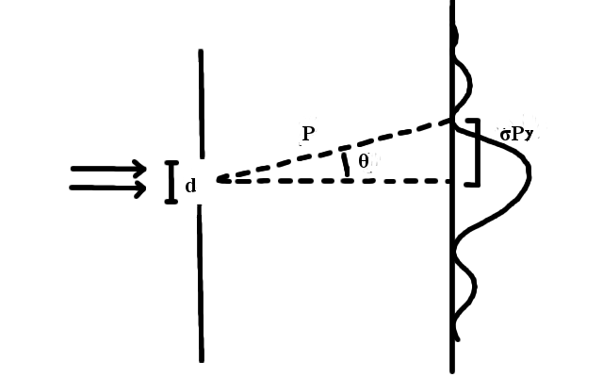

**Fig X. Cross section of single slit diffraction.** Parallel rays of light enter from the left of the figure, and contrary to classical intuition, diffuses, and creates a pattern along the right side.

The location of the first dark fringe is well known, and given by [X1]. Elementary trigonometry yielded [X2].

$d⋅sin(θ)=λ$ [X1]

Where: d = width of slit

$θ$ = angle of first dark fringe

$p⋅sin(θ)=σ_{Py}$ [X2]

Where:

Py = standard deviation of y component of momentum

Specific information is known about a photon as it passes through the single slit, namely, it’s position. This is expressed in [X3].

$σ_{y}=d$ [X3]

Where: $σ_{y}$ = position of photon

These three equations are combined with [A], and yielded the following.

$σ_{y}⋅σ_{Py}=h$ [X4]

This is a crude representation of Heisenberg’s uncertainty principle, which follows.

$σ_{y}⋅σ_{Py}≥\frac{h}{4π}$ [X5]

Some further algebra was employed to verify the theory, as σPy is rather difficult to measure directly. Certain geometries in the situation yield [X5].

$σ_{Py}=\frac{h}{λ}sin(arctan(\frac{A}{2D}))$ [X6]

Where:

D=distance between the slit and the wall

A=distance between the central two dark fringes

Substituting [X6] into [X4] and dividing by h gave

$\frac{d}{λ}sin(arctan(\frac{A}{2D}))=1$ [X7]

Experimentally obtained values λ=(630±30) nm and D=364±.2mm was then substituted, and with the addition of manufacturer provided values for the slit width, the LHS of [X7] was computed.

|  |  |  |  |
| --- | --- | --- | --- |
| Index | d(μm) | A(mm) | LHS of [10] |
| 1 | 88 | 5.2±.2 | 1.03±.05 |
| 2 | 176 | 2.6±.2 | 1.07±.05 |

**Fig X. Verifying the derived uncertainty principle.** The LHS of [X7] was computed to be very close to 1 in both scenarios, which is further evidence of the uncertainty principle.

To validate the single slit experiment, an intensity profile of an photograph was created. This profile was calibrated with **insert figure number of juliens graph**.

**Fig X. Intensity (as a percentage of max) vs position.** The intensity was calculated as a weighted average of the RGB values based off of the wavelength of the laser, which corresponded to an ideal hex code of #FF4200.

Further, the locations of the dark fringes were compared to their theoretical counterparts, and were within a margin of error.

V I FORGOT HOW TO FORMAT READING ERROR< THE MEASURED POSITION ±2 IS READING ERROR

|  |  |  |
| --- | --- | --- |
| Index | Theoretical Position (mm) | Measured Position (mm) |
| 1 | -5.2±.1 | -5.2±.2 |
| 2 | -2.61±.05 | -2.6±.2 |
| 3 | 2.61±.05 | 2.7±.2 |
| 4 | 5.2±.1 | 5.2±.2 |

**Fig X. Theoretical vs Measured Positions of Dark Fringes.** Theoretical values were computed with a generalized [X1] and experimental values were numerically obtained with a computer script.

Citaitions

Santhanam, P., Gray, D. J., & Ram, R. J. (2012). Thermoelectrically Pumped Light-Emitting Diodes Operating above Unity Efficiency. *Physical Review Letters,108*(9). doi:10.1103/physrevlett.108.097403